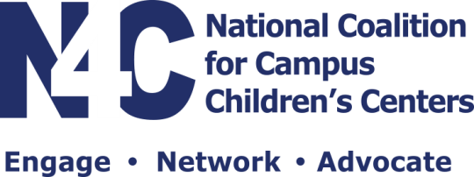
The National Coalition for Campus Children’s Centers (NCCCC) is a nonprofit educational membership organization that supports research and activities affecting college and university early childhood educational service settings, family and work issues, and the field of early childhood in general. NCCCC represents close to 600 members representing over 500 colleges and universities. As an organization we support full-funding for the federal Child Care Access Means Parents in School (CCAMPIS) program. It was recently announced that this is one of the 22 programs proposed for elimination in FY 2018 budget by the Trump administration.

The CCAMPIS program is vital in allowing student parents to balance school and family successfully. The program received a total of $15.1 million in the 2017 budget. These dollars supported 85 colleges and universities with funding to increase access to student parents.

According to the Institute for Women’s Policy Research, 53% of student parents versus 31% of non-parent students will leave college without a degree after six years and, among low-income college students, student parents are 25% less likely to obtain a degree than their low-income counterparts without children. Among the 85 colleges and universities that have CCAMPIS funding, the data is much more positive than above. CCAMPIS funding has been instrumental in increasing persistence and graduation rates among student parents at every university with this grant.

The following is an example of the impact of CCAMPIS at one University in Ohio:

- 65% of student parents would not be in school without CCAMPIS funding.
- 82% of student parents stayed in school because of CCAMPIS funding.
- 71% of student parents would not have graduated without the funding.
- 82% of student parents reported that CCAMPIS was Extremely Important to complete their degree.

One CCAMPIS Recipient stated, “I recently separated from Active Duty Air Force and moved from Okinawa Japan to Dayton Ohio. Child care while in Japan was roughly half the cost of child care in Dayton for two kids. My husband is currently Active Duty which enables us to barely meet all financial obligations to include tuition and child care. This would not be possible without the CCAMPIS grant. Without the CCAMPIS grant we would not be able to meet all financial obligations. This would require me to seek additional employment or withdraw from school. If I had to seek additional employment, I would not be able to complete the nursing program due to my Husband's work requirements. CCAMPIS is critical for our family to retain child care and enable my continued enrollment in WSU’s nursing program. Finally, I am a firm believer in supporting programs which enabled my success. After graduating and obtaining employment within nursing, I will be in a position to provide financial support toward many of WSU's programs which enabled me to enrich my life and become a more productive member in society.”

Programs, such as CCAMPIS, that support two-generations provide opportunities for and meet the needs of parents and their children together. This results in college degrees that lead to better job opportunities. Please join NCCCC in supporting the full-funding of the CCAMPIS in the 2018 budget.

Respectfully,

Dana Keller Bush, PhD
NCCCC President

